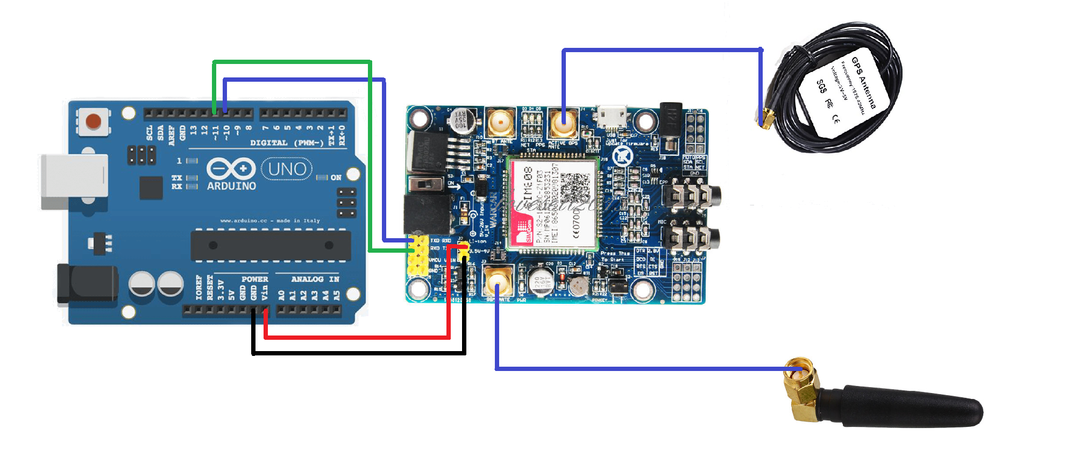

**Under Supervision :**  
Dr. Gamal Elsheikh

Dr. Mohamed Hamdy

Eng. Ahmed Fathy

**Team Members :**  
Abdelrahman Shrief – Sondos Reda – Ali Osama Mohamed Alaa – Mohamed Ramadan – Ahmed Ayman – Ahmed Tarek

**Hardware Implementation of GPS Tracking System Using SIM808 module**